MongoDB Queries:

Connecting via Terminal

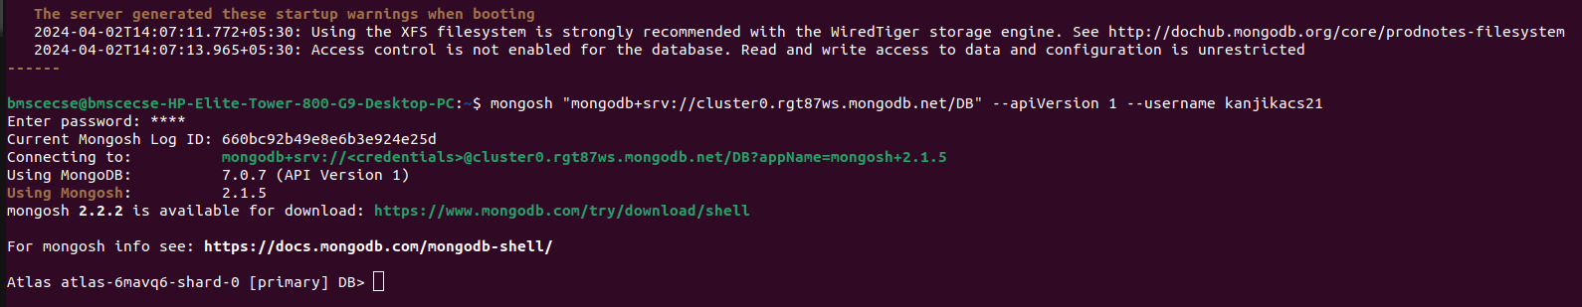

I. Perform the following DB operations using MongoDB.

1. Create a database “Student” with the following attributes Rollno, Age, ContactNo, Email-

Id.

2. Insert appropriate values

3. Write query to update Email-Id of a student with rollno 10.

4. . Replace the student name from “ABC” to “FEM” of rollno 11

II. Perform the following DB operations using MongoDB.

1. Create a collection by name Customers with the following attributes.

Cust_id, Acc_Bal, Acc_Type

2. Insert at least 5 values into the table

3. Write a query to display those records whose total account balance is greater than

1200 of account type ‘Z’ for each customer_id.

4. Determine Minimum and Maximum account balance for each customer_i

Solutions:

Atlas atlas-12eb3b-shard-0 [primary] DB> db.Student.update({rollNo:60},

{$set:{name:"Koko"}},{upsert:true});

{

acknowledged: true,

insertedId: null,

matchedCount: 1,

modifiedCount: 1,

upsertedCount: 0

}

Atlas atlas-12eb3b-shard-0 [primary] MY_DB> db.Student.find();

[

{

_id: 1,

name: Riya,

rollNo: 80,

age: 14,

phNo: '9999988888',

email: riyas@gmail.com'

},

{

_id: 2,

name: 'Vaibhav',

rollNo: 70,

age: 15,

email: 'vaibhav@gmail.com',

phNo: '8888855555'

},

{

_id: 3,

name: ‘Koko’,

rollNo: 60,

age: 14,

email: 'koko@gmail.com',

phNo: ‘9305678192’

}

]

Atlas atlas-12eb3b-shard-0 [primary] DB> db.createCollection("Customers");

{ ok: 1 }

Atlas atlas-12eb3b-shard-0 [primary] DB> db.Student.insertOne({custId:1,accBal:10000,accType:"saving"});

{

acknowledged: true,

insertedId: ObjectId('660295b055dc2f3d86c4479f')

}

Atlas atlas-12eb3b-shard-0 [primary] DB> db.Customers.insertOne({custId:1,accBal:10000,accType:"saving"});

{

acknowledged: true,

insertedId: ObjectId('660295c155dc2f3d86c447a0')

}

Atlas atlas-12eb3b-shard-0 [primary] DB> db.Customers.insertOne({custId:2,accBal:50000,accType:"current"});

{

acknowledged: true,

insertedId: ObjectId('6602960055dc2f3d86c447a1')

}

Atlas atlas-12eb3b-shard-0 [primary] DB> db.Customers.insertOne({custId:3,accBal:60000,accType:"current"});

{

acknowledged: true,

insertedId: ObjectId('6602960e55dc2f3d86c447a2')

}

Atlas atlas-12eb3b-shard-0 [primary] DB> db.Customers.insertOne({custId:4,accBal:20000,accType:"savings"});

{

acknowledged: true,

insertedId: ObjectId('6602961c55dc2f3d86c447a3')

}

Atlas atlas-12eb3b-shard-0 [primary] DB> db.Customers.insertOne({custId:5,accBal:200000,accType:"current"});

{

acknowledged: true,

insertedId: ObjectId('6602962955dc2f3d86c447a4')

}

Atlas atlas-12eb3b-shard-0 [primary] DB> db.Customers.update({custId:1},{$set:{accType:"savings"}});

{

acknowledged: true,

insertedId: null,

matchedCount: 1,

modifiedCount: 1,

upsertedCount: 0

}

Atlas atlas-12eb3b-shard-0 [primary] DB> db.Customers.find();

[

{

_id: ObjectId('660295c155dc2f3d86c447a0'),

custId: 1,

accBal: 10000,

accType: 'savings'

},

{

_id: ObjectId('6602960055dc2f3d86c447a1'),

custId: 2,

accBal: 50000,

accType: 'current'

},

{

_id: ObjectId('6602960e55dc2f3d86c447a2'),

custId: 3,

accBal: 60000,

accType: 'current'

},

{

_id: ObjectId('6602961c55dc2f3d86c447a3'),

custId: 4,

accBal: 20000,

accType: 'savings'

},

{

_id: ObjectId('6602962955dc2f3d86c447a4'),

custId: 5,

accBal: 200000,

accType: 'current'

}

]

Atlas atlas-12eb3b-shard-0 [primary]DB> db.Customers.insertOne({custId:1,accBal:30000,accType:"current"});

{

acknowledged: true,

insertedId: ObjectId('6602980955dc2f3d86c447a5')

}

Atlas atlas-12eb3b-shard-0 [primary] DB> db.Customers.insertOne({custId:2,accBal:20000,accType:"savings"});

{

acknowledged: true,

insertedId: ObjectId('6602982f55dc2f3d86c447a6')

}

Atlas atlas-12eb3b-shard-0 [primary] DB> db.Customers.update({custId:1},{$set:{accType:"savings"}});

{

acknowledged: true,

insertedId: null,

matchedCount: 1,

modifiedCount: 0,

upsertedCount: 0

}

Atlas atlas-12eb3b-shard-0 [primary] DB> db.Customers.update({custId:2},{$set:{accType:"current"}});

{

acknowledged: true,

insertedId: null,

matchedCount: 1,

modifiedCount: 0,

upsertedCount: 0

}

Atlas atlas-12eb3b-shard-0 [primary] DB> db.Customers.find();

[

{

_id: ObjectId('660295c155dc2f3d86c447a0'),

custId: 1,

accBal: 10000,

accType: 'savings'

},

{

_id: ObjectId('6602960055dc2f3d86c447a1'),

custId: 2,

accBal: 50000,

accType: 'current'

},

{

_id: ObjectId('6602960e55dc2f3d86c447a2'),

custId: 3,

accBal: 60000,

accType: 'current'

},

{

_id: ObjectId('6602961c55dc2f3d86c447a3'),

custId: 4,

accBal: 20000,

accType: 'savings'

},

{

_id: ObjectId('6602962955dc2f3d86c447a4'),

custId: 5,

accBal: 200000,

accType: 'current'

},

{

_id: ObjectId('6602980955dc2f3d86c447a5'),

custId: 1,

accBal: 30000,

accType: 'current'

},

{

_id: ObjectId('6602982f55dc2f3d86c447a6'),

custId: 2,

accBal: 20000,

accType: 'savings'

}

]

Atlas atlas-12eb3b-shard-0 [primary] DB> db.Customers.update({custId:2,accBal:30000},{$set:{accType:"savings"}});

{

acknowledged: true,

insertedId: null,

matchedCount: 0,

modifiedCount: 0,

upsertedCount: 0

}

Atlas atlas-12eb3b-shard-0 [primary] DB> db.Customers.update({custId:2,accBal:20000},{$set:{accType:"current"}});

{

acknowledged: true,

insertedId: null,

matchedCount: 1,

modifiedCount: 1,

upsertedCount: 0

}

Atlas atlas-12eb3b-shard-0 [primary] DB> db.Customers.update({custId:1,accBal:30000},{$set:{accType:"savings"}});

{

acknowledged: true,

insertedId: null,

matchedCount: 1,

modifiedCount: 1,

upsertedCount: 0

}

Atlas atlas-12eb3b-shard-0 [primary] DB> db.Customers.find();

[

{

_id: ObjectId('660295c155dc2f3d86c447a0'),

custId: 1,

accBal: 10000,

accType: 'savings'

},

{

_id: ObjectId('6602960055dc2f3d86c447a1'),

custId: 2,

accBal: 50000,

accType: 'current'

},

{

_id: ObjectId('6602960e55dc2f3d86c447a2'),

custId: 3,

accBal: 60000,

accType: 'current'

},

{

_id: ObjectId('6602961c55dc2f3d86c447a3'),

custId: 4,

accBal: 20000,

accType: 'savings'

},

{

_id: ObjectId('6602962955dc2f3d86c447a4'),

custId: 5,

accBal: 200000,

accType: 'current'

},

{

_id: ObjectId('6602980955dc2f3d86c447a5'),

custId: 1,

accBal: 30000,

accType: 'savings'

},

{

_id: ObjectId('6602982f55dc2f3d86c447a6'),

custId: 2,

accBal: 20000,

accType: 'current'

}

]

Atlas atlas-12eb3b-shard-0 [primary] DB> db.Customers.aggregate({$match:{accType:'savings'}},{$group:{_id:"$custId",TotalAccBal:{$sum:"$accBal"}}},{$match:{TotalAccBal:{$gt:20000}}});

[ { _id: 1, TotalAccBal: 40000 } ]

Atlas atlas-12eb3b-shard-0 [primary] DB> db.Customers.aggregate({$group:{_id:"$custId",minAccBal:{$min:"$accBal"},maxAccBal:{$max:"accBal"}}});

[

{ _id: 1, minAccBal: 10000, maxAccBal: 'accBal' },

{ _id: 4, minAccBal: 20000, maxAccBal: 'accBal' },

{ _id: 5, minAccBal: 200000, maxAccBal: 'accBal' },

{ _id: 2, minAccBal: 20000, maxAccBal: 'accBal' },

{ _id: 3, minAccBal: 60000, maxAccBal: 'accBal' }

]

Atlas atlas-12eb3b-shard-0 [primary] DB> db.Customers.aggregate({$group:{_id:"$custId",minAccBal:{$min:"$accBal"},maxAccBal:{$max:"$accBal"}}});

[

{ _id: 3, minAccBal: 60000, maxAccBal: 60000 },

{ _id: 4, minAccBal: 20000, maxAccBal: 20000 },

{ _id: 5, minAccBal: 200000, maxAccBal: 200000 },

{ _id: 2, minAccBal: 20000, maxAccBal: 50000 },

{ _id: 1, minAccBal: 10000, maxAccBal: 30000 }

]

Atlas atlas-12eb3b-shard-0 [primary] DB>

Student Entries

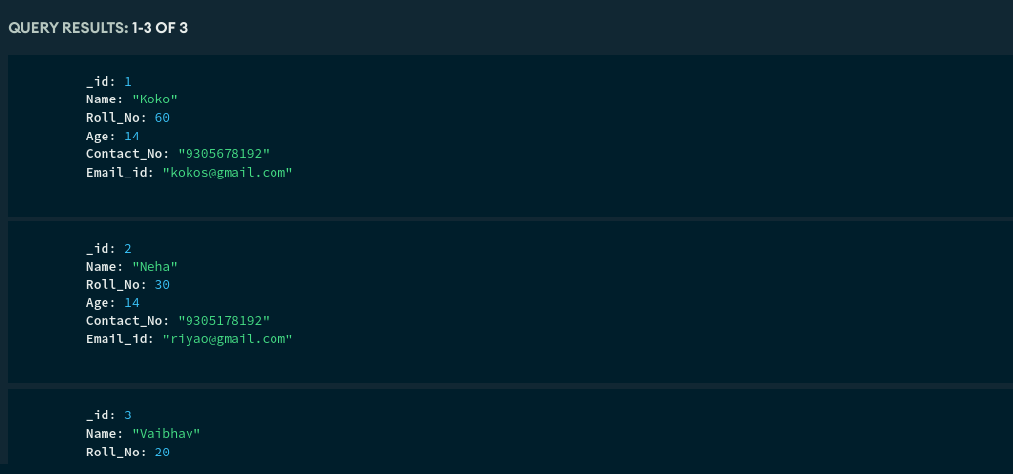

Customer Entries

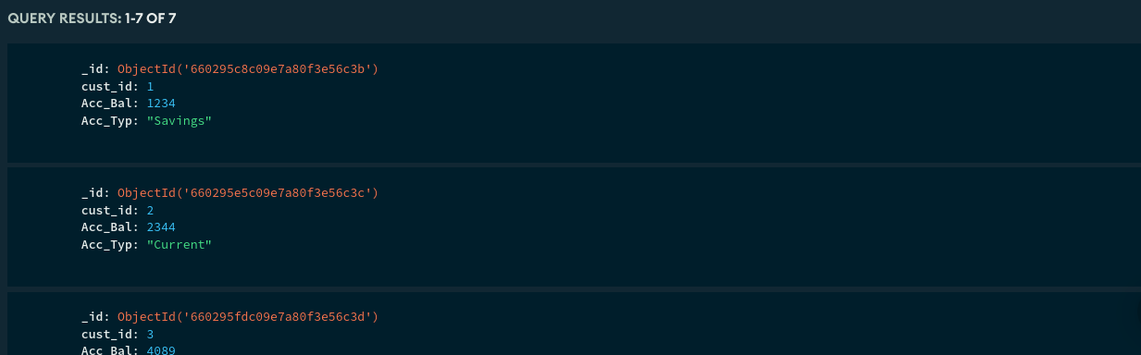

Sorting based on account balance descending:  
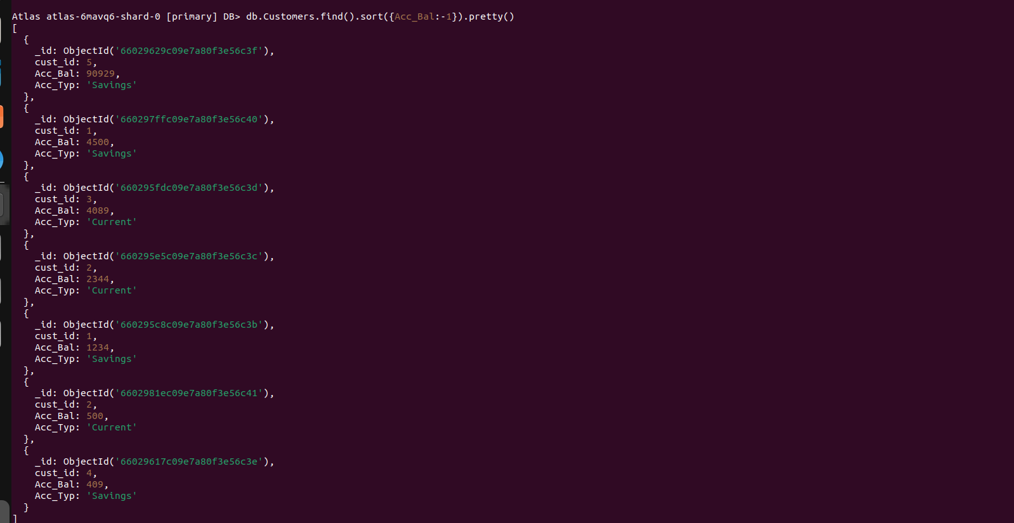

Sorting based on Customer Id aescending:

